**Interview Questions and Answers**

Q: **What is ALV IDA?**

A:

The SAP List Viewer with Integrated Data Access (ALV with IDA) offers ABAP developers the option to take advantage of SAP HANA, without having to present the user with a new or different interface.

Q: **What is difference between classical ALV and ALV IDA?**

A:

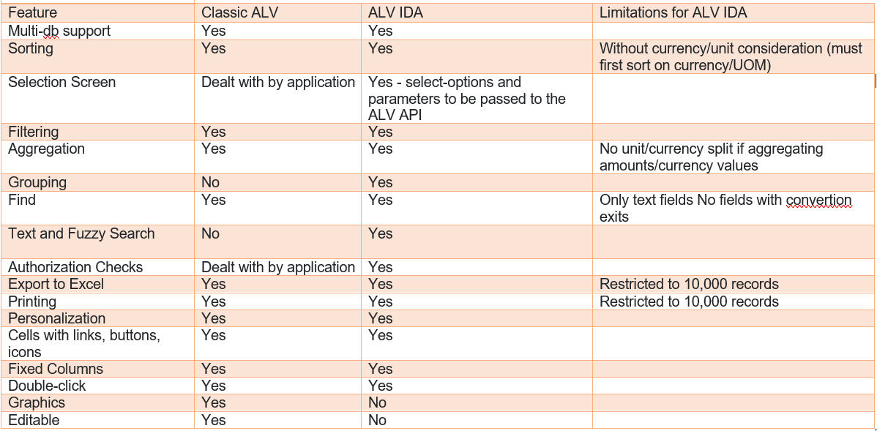

Q: **What are the benefits of using ALV IDA?**

A: ALV IDA provides several benefits over traditional ALV grids, including:

* The ability to display data from multiple tables in a single grid, without the need for complex joins or nested SELECT statements.
* Improved performance, since ALV IDA retrieves only the data that is needed to display the grid, rather than retrieving all the data from each table and performing joins in memory.
* Flexibility, since ALV IDA can be used to display data from any combination of tables or views, regardless of the underlying data model.
* Customizability, since ALV IDA provides a wide range of options for customizing the layout and behavior of the grid